GEOLOGICAL SURVEYS:
METHODOLOGICAL ORIENTATION TESTS

REPUBLIQUE DU CAMEROUN  Paix – Travail – Patrie  -------------------------  COOPERATION CAMEROUN – BANQUE MONDIALE  -------------------------  MINISTERE DES MINES, DE L’INDUSTRIE ET DU DEVELOPPEMENT TECHNOLOGIQUE  -------------------  PROJET DE RENFORCEMENT DES CAPACITES  DANS LE SECTEUR MINIER |  | REPUBLIC OF CAMEROON  Peace – Work - Fatherland  -------------------------  CAMEROON – WORLD BANK COOPERATION  -------------------------  MINISTRY OF MINES, INDUSTRY AND TECHNOLOGICAL DEVELOPMENT  ----------------  THE MINING SECTOR CAPACITY  BUILDING PROJECT

WARNING

This report was prepared within the framework of the implementation of a geological and geochemical mapping programme and the implementation of a Geological and Mining Information System in Cameroon by the BRGM/GTK/BEIG3 group. Its references are:

Vic G., Joannes C., Fournier E., Chevillard M. (2017) - Geological and Geochemical Mapping Programme and implementation of a Geological and Mining Information System in Cameroon. Report of the preparatory phase - Geochemical and alluvial survey of the centre north of Cameroon: Results of the methodological orientation tests - Part 2. BRGM/RC-66987-EN. 40 p., 26 fig., 2 tab., 2 appendices.

Contents

Preamble

WARNING

Contents

PREAMBLE

1. OBJECTIVES
2. METHODOLOGICAL AND ORIENTATION TEST
2.1. Selection of Indicators and Feld Work of the Methodological Orientation Test
2.2. Granulometric Analysis and Composition
2.3. Chemical Composition
2.3.1. Analysis of Prepared and Calculated Fractions
2.4. Cartographic Approach
3. CONCLUSIONS

List of figures

Figure 1: Location of the indicator sampled during the methodological orientation test and the trace performed on a 90m SRTM background.
Table 1: Summary table of pre-treatment of samples taken during the orientation methodological test in December 2016. TR: Very Rare; R: Rare; M: Medium; A: A: Abundant; TA: Very abundant.
Figure 2: Distribution of grain size classes by weight % of dry test samples of orientation methodology.
Figure 3: Diagram of aluminium contents in the different size fractions analyzed and calculated for each sample
Figure 4: Diagram of iron contents in the different size fractions analysed and calculated for each sample.
Figure 5: Diagram of the "pseudo-silica" contents calculated in the different size fractions for each sample.
Figure 6: Diagram of gold contents in the different size fractions analysed and calculated for each sample.
Figure 7: Diagram of chromium contents in the different size fractions analysed and calculated for each sample.
Figure 8: Diagram of copper contents in the different size fractions analysed and calculated for each sample.
Figure 9: Diagram of tin contents in the different size fractions analysed and calculated for each sample.
Figure 10: Diagram of tantalum contents in the different particle size fractions analysed and calculated for each sample.
Figure 11: Diagram of zinc contents in the different size fractions analysed and calculated for each sample.
Figure 12: Diagram of nickel contents in the different size fractions analysed and calculated for each sample.
Figure 13: Gold content of the analyzed fraction < 63 µm of stream sediments collected at Mborguéné
Figure 14: Gold content of the calculated fraction < 125 µm of stream sediments collected at Mborguéné.
Figure 15: Gold content of the calculated fraction < 250 µm of stream sediments collected at Mborguene.
- Hosséré Paali (figures 16, 17, 18):
Figure 16: Zinc content of the analyzed fraction < 63 µm of stream sediments collected at Hosséré Paali.
Figure 17: Zinc content of the calculated fraction < 125 µm of stream sediments collected at Hosséré Paali.
Figure 18: Zinc content of the calculated fraction < 250 µm of stream sediments collected at Hosséré Paali.
- Mayo Darlé (figures 19, 20, 21):
Figure 19: Tin content of the analyzed fraction < 63 µm of stream sediments collected at Mayo Darlé
Figure 20: Tin content of the calculated fraction < 125 µm of stream sediments collected at Mayo Darlé.
Figure 21: Tin content of the calculated fraction < 250 µm of stream sediments collected at Mayo Darlé
- Otélé (figures 22, 23, 24)
Figure 22: Titanium content of the analyzed fraction < 63 µm of stream sediments collected at Otélé.
Figure 23: Titanium content of the calculated fraction < 125 µm of stream sediments collected at Otélé.
Figure 24: Titanium content of the calculated fraction < 250 µm of stream sediments collected at Otélé.
Figure 25: Quality control on sample 01-2 taken at Mborguéné and its laboratory duplicate 04-2 compared to the linear trend function R²=1.
Figure 26: Quality control on sample 23-4 taken at Hosséré Paali and its laboratory duplicate 24-4 compared to the linear trend function R2=1.

List of Tables
Table 1: Summary table of pre-treatment of samples taken during the orientation methodological test in December 2016. TR: Very Rare; R: Rare; M: Medium; A: A: Abundant; TA: Very abundant.
Table 2: Results of the analysis of the methodological orientation test (1/3).
Table 2 (cont’d) : Results of the analysis of the methodological orientation test (2/3).
Table 2 (cont’s and end): Results of the analysis of the methodological orientation test (3/3).

Preamble

Cameroon has in the past been a producer of mineral substances, in particular gold, tin and titanium. Today, national mineral production is totally limited to hydrocarbons ("liquid" mine) whose production was estimated in 2018 at 25 million barrels of oil and about 2 billion cubic metres of gas, building materials and non-industrial gold and diamond production. As for oil production, it is stagnant or even declining, and in the coming years, Cameroon faces the prospect of the exhaustion of known reserves. The major challenge for the Cameroonian government is therefore to develop the "solid" mine and build a sustainable mining industry, integrating all the links in the chain (production, processing, marketing), in order to eventually take over from the post-oil era.

In the search for solutions, the Government of the Republic of Cameroon, with the support of the World Bank, set up the Mining Sector Capacity Building Project (PRECASEM) whose main objectives are to contribute to the recovery of Cameroon's mining sector, in particular by improving geological and mining information. This task involves airborne geophysical surveys on the one hand, and geological and geochemical mapping, on the other hand, at a scale of 1:200,000.

While geological mapping enables to differentiate and plot the main rocks encountered and after laboratory study, to characterize them and determine their possible content, geochemical prospecting, which takes place simultaneously in the field, enables to identify points of abnormal enrichment in relation to the natural geochemical background (variable from one region to another depending on the nature of the geological formations present.

Geochemistry, particularly stream sediment geochemistry, is therefore an important tool for mineral exploration. However, its use raises several questions: the usefulness of stream sediments in different settings, the choice of the elements and medium (fine fractions vs. heavy minerals) to be sampled, and the determination of appropriate anomaly thresholds, are examples of topics to consider in exploration.

As part of the 2016-2018 Geological and Geochemical Mapping Campaign, a preliminary orientation study was conducted to determine a modus operandi for general survey based on international best practices.

This Manual that you are holding addresses this need. It includes the location and description of the geological environment of the sampling sites, sample preparation and conservation, data reporting, etc. The results and interpretations resulting from these analyses concern:
- analysis of the granulometric composition of the samples;
- the presentation of diagrams of major elements and traces for all the size fractions analysed and calculated;
- the cartographic approach of the results of analyses of the main elements of each indicators sampled;
- a conclusion on the grain size fraction selected and a recommendation on the minimum amount of stream sediment to be sampled.
I have no doubt that this Manual and the methodology it promulgates will make a significant contribution to the geochemical prospecting work that you will have to carry out in Cameroon.

Gabriel DODO NDOKE
Minister of Mines, Industry and
Technological Development

1. OBJECTIVES

The technical objectives of a stream and alluvial sediment geochemical survey are to determine the geochemical characteristics of the bedrock of the lands that constitute the watershed basins of the sampled drainages, help define the metallogenic provinces and identify potential exploration areas. The preliminary orientation study envisaged within the framework of the implementation of a geological and geochemical mapping programme and the establishment of a Geological and Mining Information System in Cameroon by the BRGM/GTK/BEIG3 group, should therefore provide a basic reference in a region where the contribution of industrial contaminants is minimal.

The methodological tests were carried out on 4 already known indicators in order to precisely define the sampling method, in particular the size fraction best adapted to the targets sought.

These tests also enabled to quantify the percentage of the different particle size fractions in the samples all in order to define the quantity of material to be collected during the field phase to ensure that the necessary quantities were obtained for primary analyses, control analyses and check samples.

In the watersheds around the 4 selected indicators, samples were collected at different distances (1 km, 2.5 km, 5 km) and each sample was used to prepare several samples that were then separated by grain size ranges, each analyzed for gold and multi-elements. The number of analyses required for these methodological calibration tests between 40 and 50 was estimated between 40 and 50.

The choice of sites for geochemical tests was made taking into account the different geomorphological units of the area to be prospected and mapped.

The ultimate objective of these tests, which is to ensure that the different types of mineralization are geochemically detectable by the selected method, is discussed in Chapter 1.

Chapter 2 presents the results of the orientation methodological test and has four parts. The first part is a reminder of the selection of indicators and the field work of the orientation methodological test. The analysis of the granulometric and geochemical composition of the collected samples concerns two distinct parts. Finally, a mapping approach with the results of the substances targeted on each index sampled is proposed.

Chapter 3 concludes with the results of the orientation test interpretation and the grain size fraction chosen for systematic geochemical analyses on stream samples.

2. Methodological and orientation test

2.1. SELECTION OF INDICATORS AND FIELD WORK OF THE METHODOLOGICAL ORIENTATION TEST

Four all the indicators listed in Cameroon (GIS-Africa database) were chosen because they were the subject of detailed prospecting work carried out by BRGM in the past and associated reports. In addition to the reality and assurance of the correct positioning of the targeted indicators, the choice was also made on the basis of the substance, the environment and accessibility (Figure 1).

The sites selected are:
- Otélé (Ti): The Otélé titanium district represented by numerous alluvial rutile indicators, is located 40 km southwest of Yaounde in micaschist to muscovite, biotite, garnet and sometimes disthene formations. The size of the sampled watershed is approximately 15 km², which corresponds to an equivalent surface area of the watersheds of the field season. The equatorial forest environment is representative of the topographical maps to the south of the study area. The three planned samples (TST034, TST035, TST036) could be collected, but the marshy environment made collection difficult due to the high presence of organic matter.

- Mborguéné (Au): Located in east Cameroon, in the Betare Oya SubDivision and 35 km from the border with Central African Republic, this alluvial gold indicator currently has an exploration permit for a primary deposit held by CAMINCO. The three planned samples (TST001, TST002, TST003) could be collected, but due to the presence of gold washing areas showing more extensive mineralization than expected, the sampling points were slightly shifted upstream. Indeed, former alluvial gold mining operations have strongly influenced the riverbed.

- Hosséré Paali (Pb, Zn + Fe, Mn, P): located between Meiganga and the Central African border, in a volcano-sedimentary belt, this indicator was recognized by soil geochemistry grid, trenches and geophysics by BRGM (Vairon, 1986; Pinna, 1989). The anomaly is located just downstream a 15 km² watershed, with a surface area close to or equivalent to the watersheds of the field season. The three planned samples (TST021, TST022, TST023) could be taken at the points initially targeted. The particularly sandy environment made sampling difficult for the points located on the Sessign River.

- Mayo Darlé (Sn): Located 40 km southwest of Banyo and 15 km from the border with Nigeria, this is the area of the former Mayo Darlé alluvial tin mine on slightly deformed or not coarse-grained granite formations. The wooded savannah environment is representative of the topographic maps in the northern part of the study area. The three planned samples (TST041, TST042, TST043) successfully taken at the points initially targeted.

For each indicator, 3 samples were collected at different distances (500 m, 2.5 km and 5 km) from the indicator on the same collector. This makes a total of 12 planned samples that were each analyzed for 4 particle size fractions (< 63 µm, 63-125 µm, <125 - 250 µm and 250 - 500 µm). In addition, two samples were duplicated at the processing laboratory for inclusion as quality control in the series shipped to the geochemical analysis laboratory (Table 1).

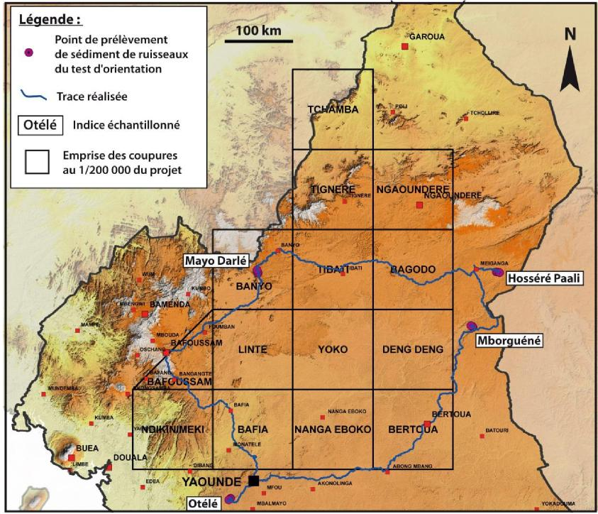
Figure 1: Location of the indicator sampled during the methodological orientation test and the trace performed on a 90m SRTM background.

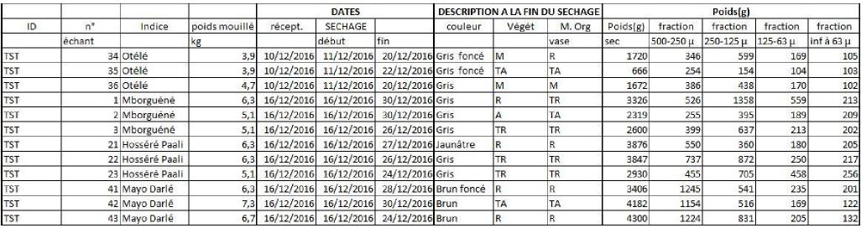
Table 1: Summary table of pre-treatment of samples taken during the orientation methodological test in December 2016. TR: Very Rare; R: Rare; M: Medium; A: Abundant; TA: Very abundant.

2.2. GRANULOMETRIC ANALYSIS AND COMPOSITION

The particle size composition of the raw samples of the methodological orientation test shows, with the exception of samples TST34, TST35 and TST01, a dominance of the coarsest fraction (> 500 µm) for the majority of samples (Figure 2). This fraction represents between 8 and 67% of the weight of the dry samples despite sediment sampling in the field targeted on the finest fraction. This is the fraction called "500 µm screen rejection" that was not sent to the assay laboratory.
The grain size fraction between 500 and 250 µm constitutes between 11 and 38% of the weight of the samples.

Since a 250 µm field pre-sizing is considered when sampling in the dry season on the northernmost topographic maps, particular attention should be paid to fractions below 250 µm, which represent between 19 and 64% of the weight of the raw samples. The fraction less than 125 µm represents between 7 and 31% and the fraction less than 63 µm represents between 6 and 15% of the weight of the samples.

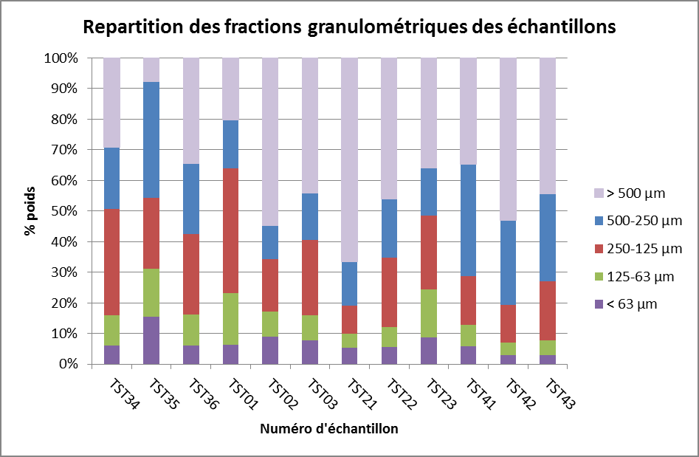
Figure 2: Distribution of grain size classes by weight % of dry test samples of orientation methodology.

2.3. CHEMICAL COMPOSITION

The 50 samples (48 samples plus 2 duplicates) prepared in Yaounde were sent to ALS-Minerals-Geochemistry's certified commercial laboratory in Loughrea (Ireland) on 20/3/2017.

For each sample, the analyses performed are as follows:
- Analysis of 48 elements (Ag, Al, As, Ba, Be, Bi, Ca, Cd, Ce, Ce, Co, Cr, Cs, Cu, Fe, Ga, Ge, Hf, In, K, La, Li, Mg, Mn, Mo, Na, Nb, Ni, P, Pb, Rb, Re, S, Sb, Sc, Se, Sn, Sr, Sr, Ta, Ta, Te, Th, Ti, Tl, U, V, W, Y, Zn, Zr) after quadriacid attack and assay ICP-AES/ICP-MS ;
- Au analysis at 1 ppb (detection limit) on 25 g of sample. Extraction with aqua regia and dosage with ICP-MS.

2.3.1. Analysis of prepared and calculated fractions
For each raw sample, 4 particle size fractions were analyzed (500 - 250 µm; 250 - 125 µm; 125 - 63 µm and < 63 µm) and 2 fractions were calculated (< 250 µm and < 125 µm). Indeed, for practical purposes, the chemical compositions were recalculated according to the respective weight of each size fraction analysed.
Several major chemical elements and traces representative of different metallogenic settings are presented in the form of diagrams for each fraction analyzed and calculated per sample.

- Major elements :
For aluminium, the fraction < 63 µm shows a systematic enrichment between 1 and 4% compared to the coarser fractions (Figure 3). This major element, which can determine the presence of bauxite, is also used in the composition of clays, which are more commonly found in fine fractions.

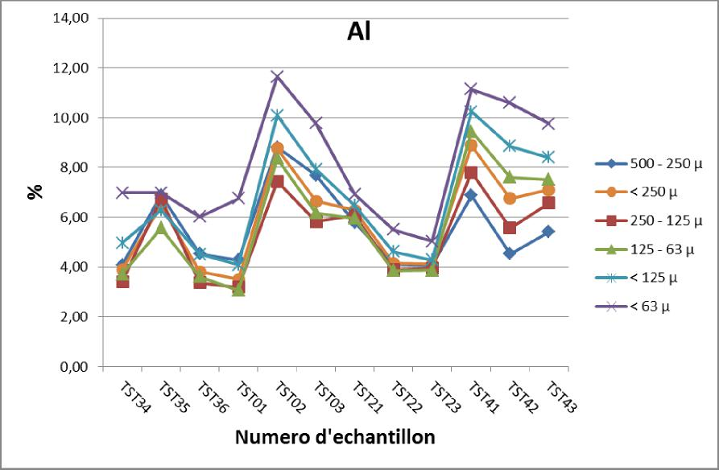

Figure 3: Diagram of aluminium contents in the different size fractions analyzed and calculated for each sample

For iron, fine fraction < 63 µm is the one that consistently has the highest concentrations (Figure 4). The exception for TST21 sample is attributed to the presence of lateritic granules in the sampled stream that overestimate the response of iron in the coarsest fractions.
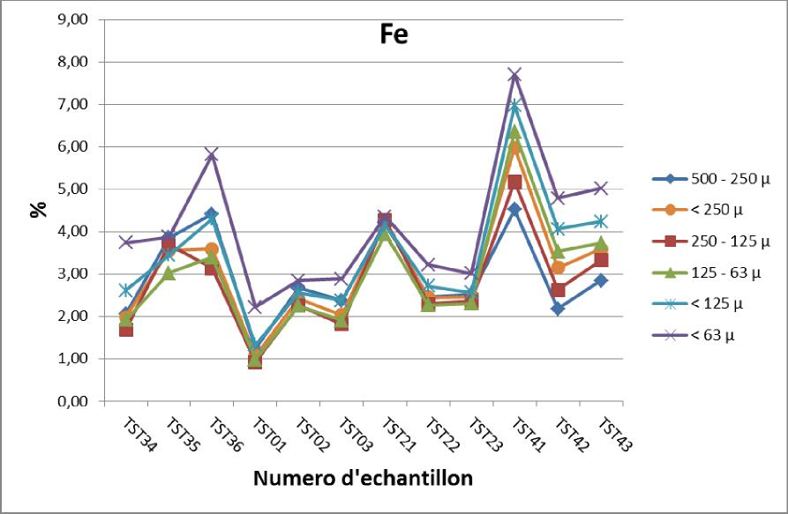
Figure 4: Diagram of iron contents in the different size fractions analysed and calculated for each sample.

The term "pseudo-silica" corresponds to the 100% residue of the major elements analyzed converted into oxide. This is approximately the sum of the contents in silica (SiO2), carbon dioxide (CO2), mineralogical water (H2O) and organic compound (organic carbon and plant residues). Given that silica is the dominant component of this supplement, the extended term "pseudo-silica" is used.

According to the "pseudo-silica" content diagram, the fraction < 63 µm is clearly the poorest in "pseudo-silica" for all samples (Figure 5). This underlines the fact that the fine fraction is almost systematically the richest in major chemical elements and traces. The coarsest fractions (500 - 250 µm and 250 - 125 µm) are richer in "pseudo-silica" because they contain more sand. This is particularly the case for samples TST41, TST42 and TST43 taken at Mayo Darlé in a very sandy stream.
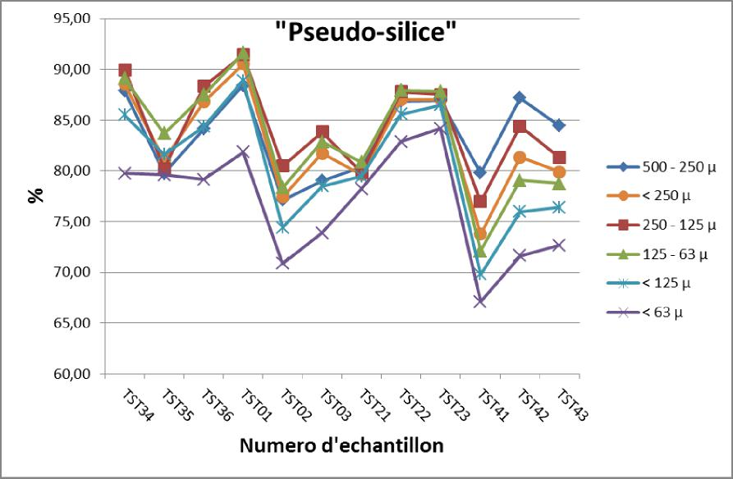
Figure 5: Diagram of the "pseudo-silica" contents calculated in the different size fractions for each sample.

- Trace elements :
The indicatir sampled for the orientation test that corresponds to known gold mineralization is the Mborguéné index (TST01, TST02 and TST03). For reasons of strong remobilizations attributed to the current alluvial gold washing, the dispersion of gold for this indicator is hard to interpret. On the other hand, the fine fraction < 63 µm is the richest with the fraction < 125 µm which also marks the anomalies (Figure 6). The TST22 sample, located in the Hosséré Paali, district shows a peak well marked by the coarsest fraction 500 - 250 µm which is also marked to a lesser extent by the finest fractions.

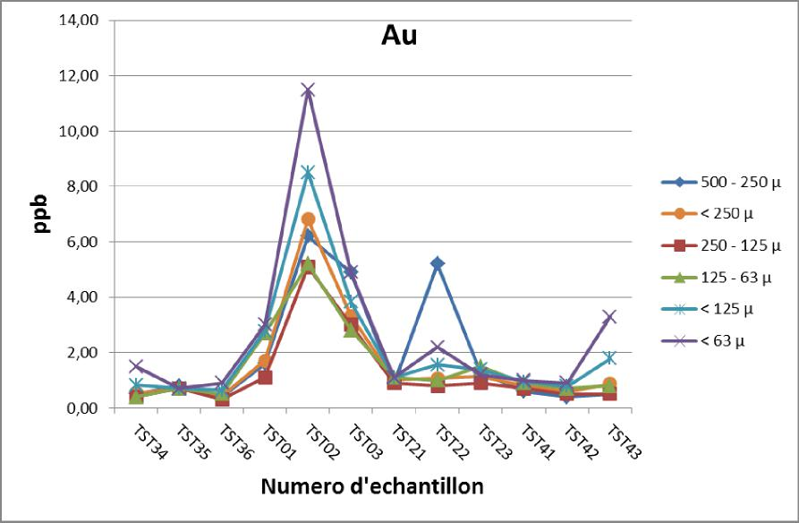
Figure 6: Diagram of gold contents in the different size fractions analysed and calculated for each sample.

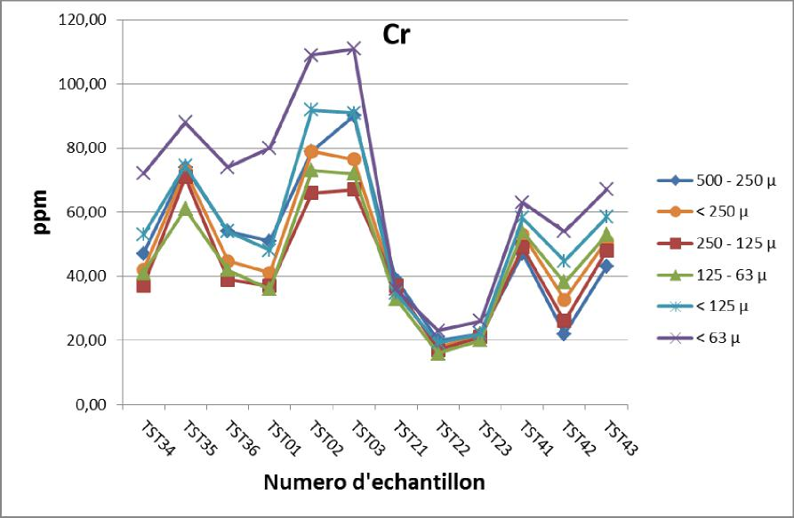
Figure 7: Diagram of chromium contents in the different size fractions analysed and calculated for each sample.

For chromium, no indication of the methodological orientation test was targeted for this element. On the other hand, chromium is particularly present in the so-called "ultrabasic" formations, which gives it an important lithogeochemical interest. Exception for samples TST21, TST22 and TST23 where the values between the different fractions is quite slightly different, the fraction < 63 µm responds best with enrichment greater than 20 ppm for samples of Otélé and Mborguéné (Figure 7).

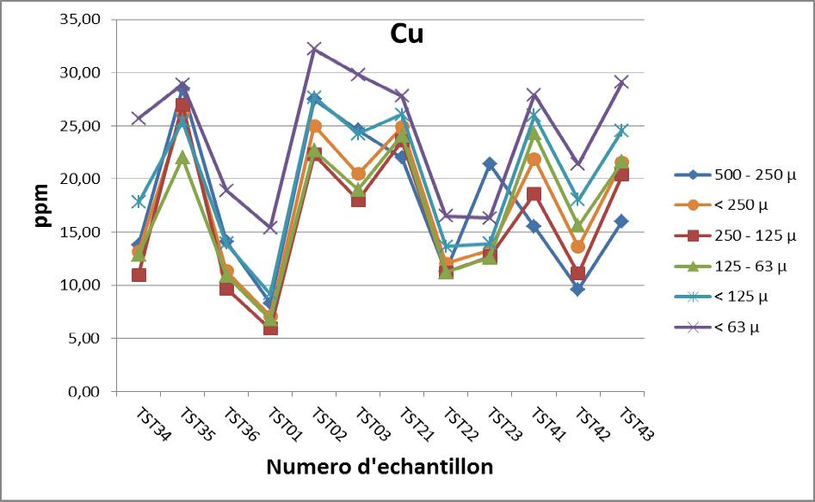
Figure 8: Diagram of copper contents in the different size fractions analysed and calculated for each sample.

For copper, the fine fraction < 63 µm is the richest for all samples except TST23 where the coarsest fraction is the richest. It should be noted that the coarse fraction (500 - 250 µm) also shows good results for the Otélé and Mborguéné indicator (Figure 8). The Hosséré Paali base metal indicator shows a high dispersion between the TST21 sample taken at 500 m from the indicator and the TST22 sample taken 2.5 km from the indicator in a larger watercourse.

Tin was tested on the former alluvial farm of Mayo Darlé (TST41, TST42 and TST43). When the geochemical response is low, all fractions have a response that is fairly close to each other (Figure 9). On the other hand, for samples taken at Mayo Darlé where the cassiterite (SnO2) concentration is higher, the fine fraction has the highest response while the coarsest fraction has the lowest response. As the numerous alluvial flats operations have considerably remobilized the environment, it is not possible to evaluate the geochemical dispersion of tin for this indicator.
Figure 9: Diagram of tin contents in the different size fractions analysed and calculated for each sample.

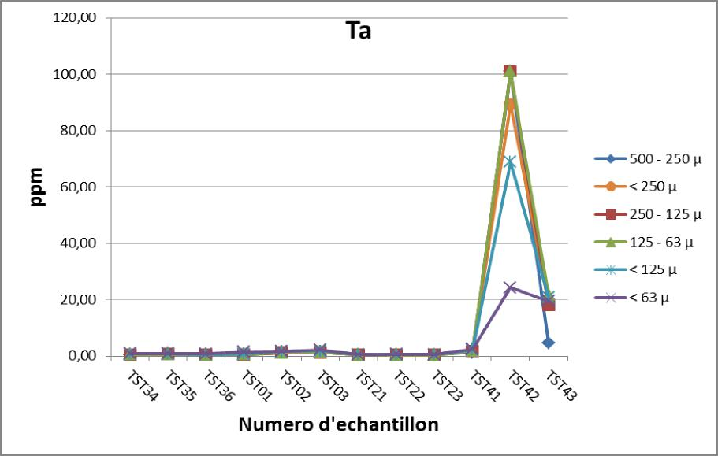
Figure 10: Diagram of tantalum contents in the different particle size fractions analysed and calculated for each sample.

For tantalum, exception for samples collected at Mayo Darlé, the geochemical response for the other indicator is relatively low and ranges from 0.39 to 0.80 ppm (Figure 10). For the Mayo Darlé indicator, whose granitic and pegmatitic environment justifies the presence of tantalum, tin, niobium, beryllium and other associated elements, the geochemical response is much higher. The TST41 and TST43 samples show a homogeneous response between the different fractions. On the other hand, for the TST42 sample taken at a flat enriched in heavy minerals, fractions above 125 µm have a response between 68 and 101 ppm (maximum detection limit) and the fine fraction < 63 µm has a 24 ppm response. Despite such a difference in tantalum concentration in the fine fraction, the anomaly is still quite prominent.
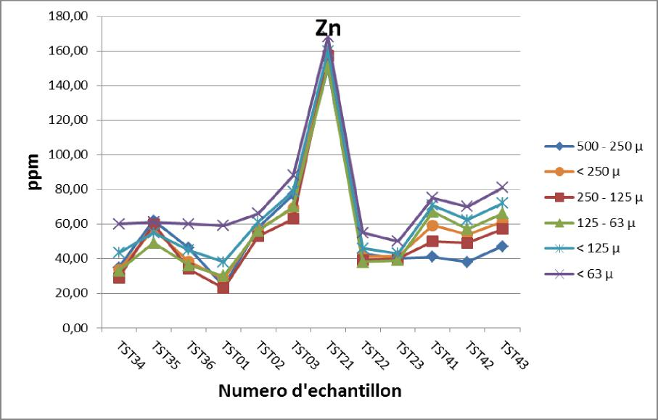
Figure 11: Diagram of zinc contents in the different size fractions analysed and calculated for each sample.

For zinc, the coarse and intermediate fractions have heterogeneous responses while the fine fraction < 63 µm is systematically the most stable and highest (Figure 11). The index sampled for base metals at Hosséré Paali shows a peak anomaly for the TST21 sample and a high dilution of the geochemical response for the TST22 and TST23 samples taken from the main Sessign stream.

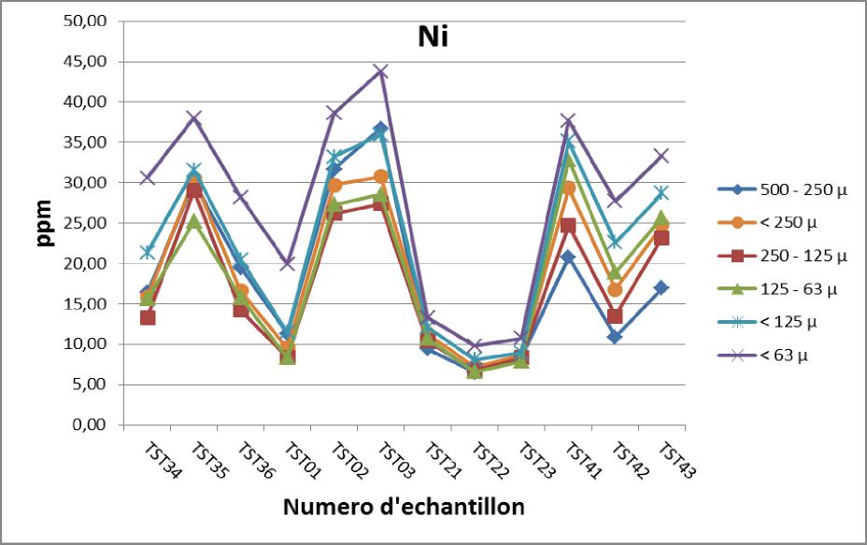
Figure 12: Diagram of nickel contents in the different size fractions analysed and calculated for each sample.

Nickel, in addition to being an element of mining interest, is also a very good lithogeochemical marker for basic formations. The samples from the methodological orientation test clearly indicate that the fine fraction is always the richest and most contrasted while the intermediate and coarse fractions have a lower response (Figure 12). The Hosséré Paali index (TST21, TST22, TST23) collected in metasedimentary series is relatively low in nickel.

2.4. CARTOGRAPHIC APPROACH

The results of the analysis of the fraction < 63 µm and the results calculated for the fractions < 125 µm and < 250 µm are recorded on the topographic sampling maps of the 4 indicators collected.

- Mborguene (figures 13, 14, 15):
The Mborguéné gold indicator is highlighted by the TST42 sample, which is geographically closest to the indicator. The fraction < 63 µm has the highest value (11.5 ppb) but also allows an anomalous response up to 2.5 km from the indicator, which is not the case for fractions < 125 and < 250 µm. The TST01 sample was voluntarily placed upstream the known indicator in order to avoid all samples being collected in exploited areas.

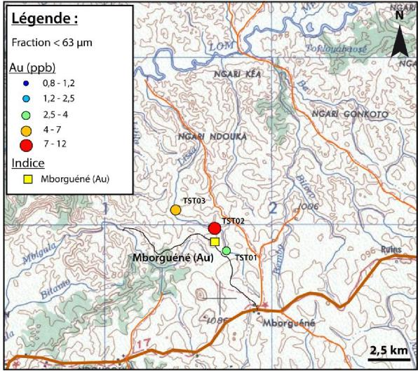
Figure 13: Gold content of the analyzed fraction < 63 µm of stream sediments collected at Mborguéné

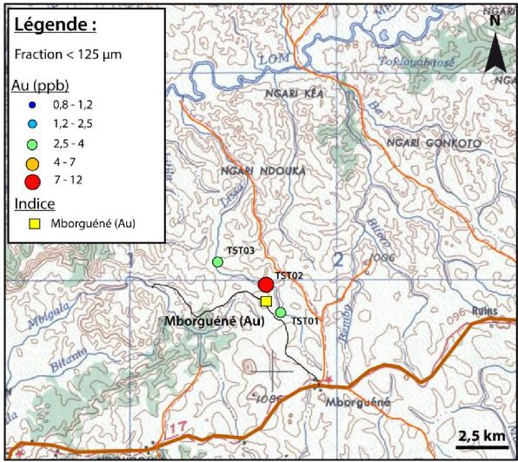
Figure 14: Gold content of the calculated fraction < 125 µm of stream sediments collected at Mborguéné.
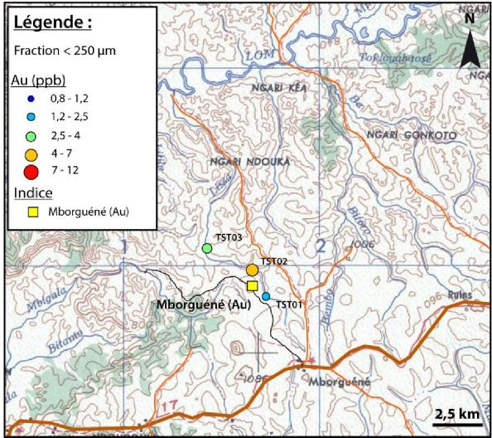
Figure 15: Gold content of the calculated fraction < 250 µm of stream sediments collected at Mborguene.

- Hosséré Paali (figures 16, 17, 18):

Hosséré Paali's lead-zinc-copper base metal indicator is very prominent in all fractions by the TST21 sample collected at about 500 m from the indicator. On the other hand, due to a significant dilution of sediments from Hosséré Paali in the Sessign, the geochemical response shows a significant decrease in the TST22 and TST23 samples at 2.5 km and 5 km respectively from the indicator. Only the fine fraction still allows for a low anomalous response above the regional geochemical backgound.

For lead (not shown on the map), the results are very similar to those of zinc. On the other hand, since lead is less mobile than zinc, the anomalous geochemical signal is no longer perceptible in the TST22 and TST23 samples for all fractions.

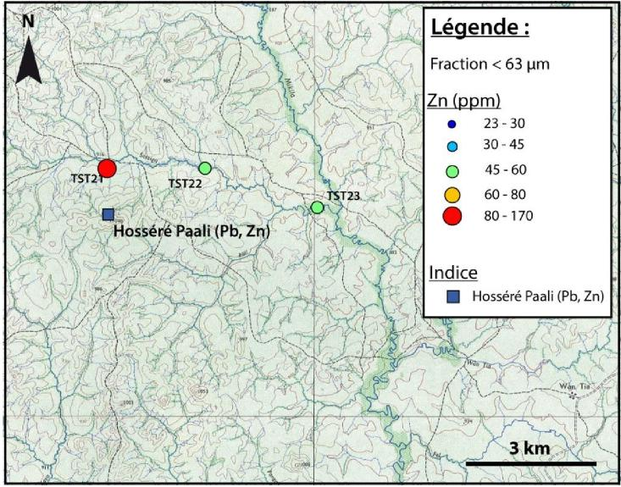
Figure 16: Zinc content of the analyzed fraction < 63 µm of stream sediments collected at Hosséré Paali.
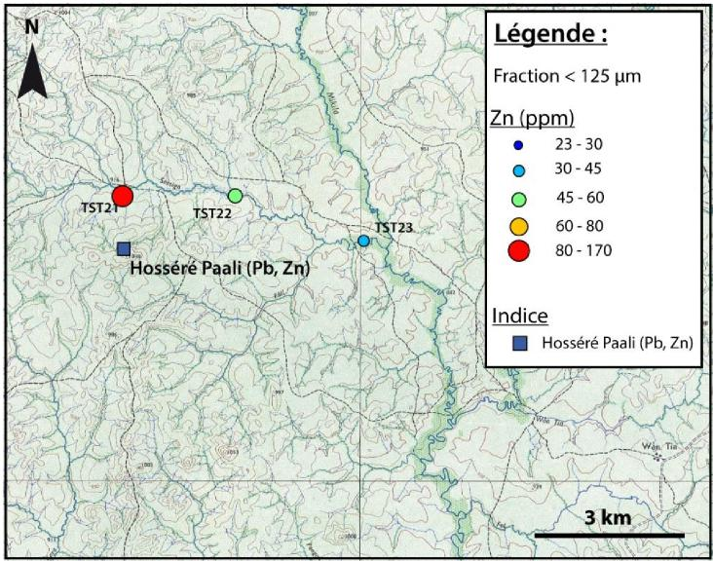
Figure 17: Zinc content of the calculated fraction < 125 µm of stream sediments collected at Hosséré Paali.

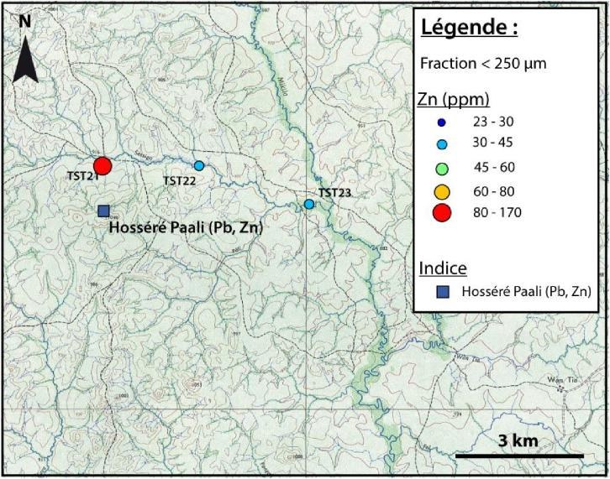
Figure 18: Zinc content of the calculated fraction < 250 µm of stream sediments collected at Hosséré Paali.

- Mayo Darlé (figures 19, 20, 21):
The Mayo Darlé tin indicator represents a surface area covering several small watersheds comprised of alluvial flats exploited for cassiterite. The results show that the particle size fraction < 63 µm is systematically the richest and that the responses of the calculated fractions < 125 and < 250 µm are close to each other. The TST43 sample located the furthest downstream the flats previously exploited has a response between 15 and 20 ppm for all size fractions. The TST041 sample was deliberately placed upstream of a previously exploited flat in order to better constrain the fraction with the best response outside the influence of a potential remobilization. The fine fraction is the richest.
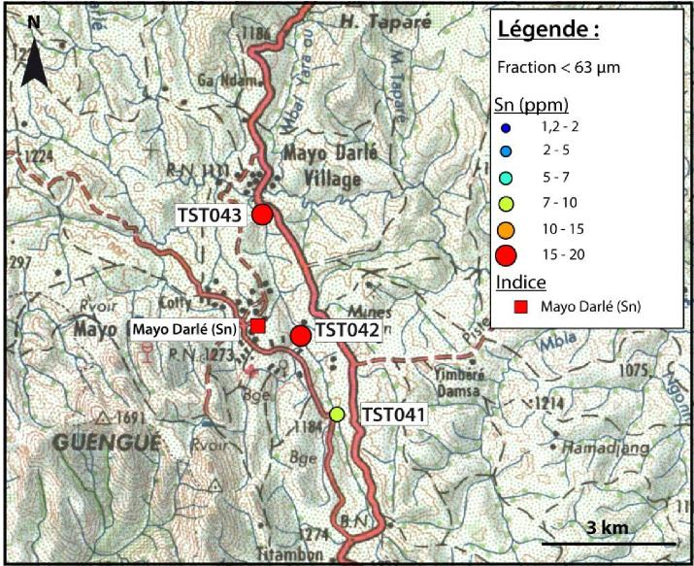
Figure 19: Tin content of the analyzed fraction < 63 µm of stream sediments collected at Mayo Darlé

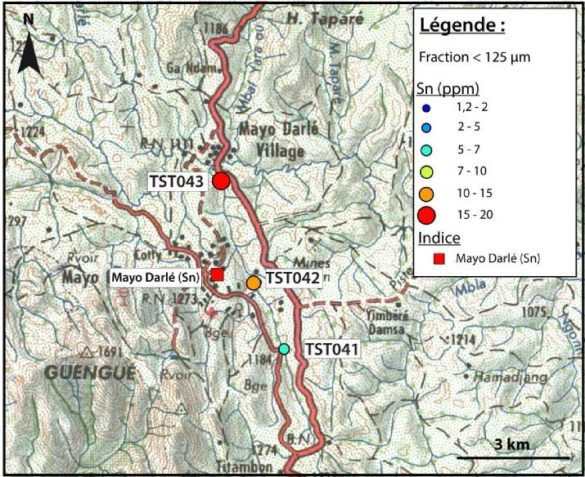
Figure 20: Tin content of the calculated fraction < 125 µm of stream sediments collected at Mayo Darlé.
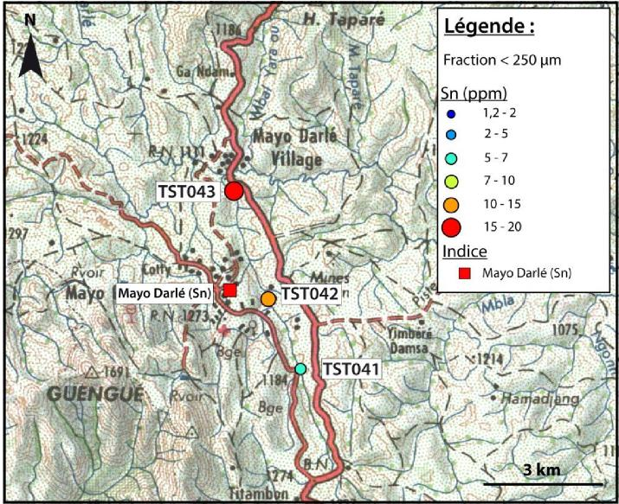
Figure 21: Tin content of the calculated fraction < 250 µm of stream sediments collected at Mayo Darlé

- Otélé (figures 22, 23, 24)
The alluvial rutile district of Otélé covers several catchment areas. Analyses show that the fine fraction has a much richer titanium response than the coarser fractions. The highest value is 0.50% for the < 63 µm fraction of the TST034 sample, the lowest value is 0.28% for the < 250 µm fraction of the TST036 sample. The anomaly is clearly marked by the fine fraction with results above the anomalous threshold of 0.36%. The fraction < 125 µm marks the anomaly very slightly with only two results above the threshold for samples TST034 and TST035 with values of 0.38% and 0.42% respectively.

The quantity of alluvial indicators and rutile placers mapped in the district does not allow conclusions to be drawn about the dilution of the anomalous signal as a function of distance from the indicator.

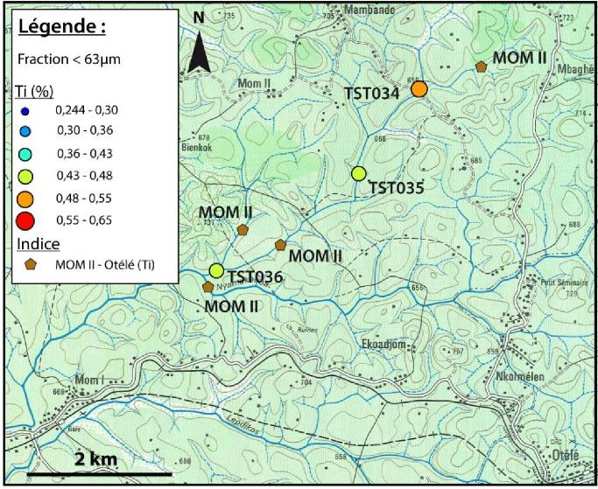
Figure 22: Titanium content of the analyzed fraction < 63 µm of stream sediments collected at Otélé.
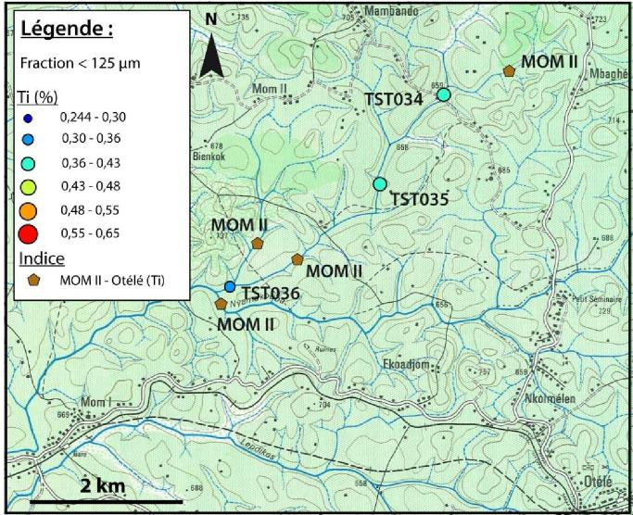
Figure 23: Titanium content of the calculated fraction < 125 µm of stream sediments collected at Otélé.

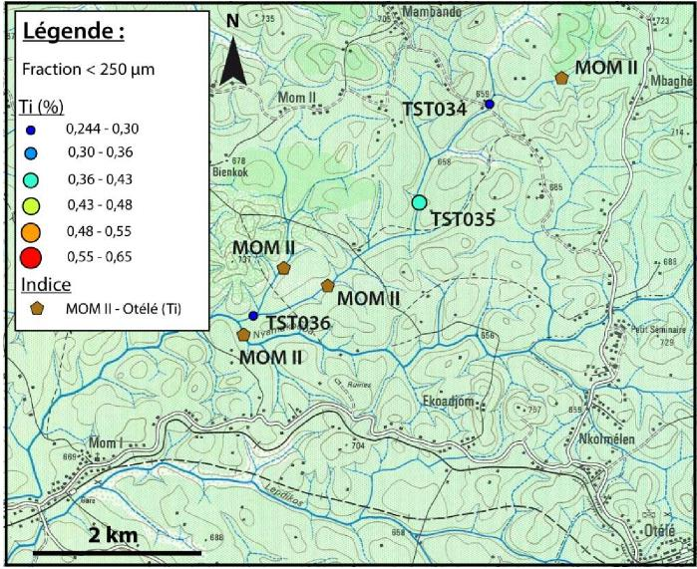
Figure 24: Titanium content of the calculated fraction < 250 µm of stream sediments collected at Otélé.

3. Conclusions

The results of the analysis of the orientation methodological test samples collected in various metallogenic environments and settings show that the fine fraction less than 63 µm gives the most contrasted and highest responses.

The calculated fractions < 125 µm and < 250 µm have relatively similar responses that do not systematically highlight metal anomalies targeted on the sampled indicators.

The fraction less than 63 µm represents between 6 and 15% of the weight of the dry samples, i.e. between 102 and 256 grams for all the samples in the methodological test. In order to send a minimum of 60 grams to the analytical laboratory and to keep a control, it will be necessary to collect at least 3 kg dry. Since a pre-screening at 250 µm in the field is envisaged in the dry season on the most northern topographic maps, a sample of at least 1 kg dry may be taken.

After consultation between the technical teams and the teams of the sample preparation laboratory, the fraction less than 63 µm is used for all analyses of the stream samples of the geochemical survey project in centre-north of Cameroon.

- Bibliography

ITARD Y., LABBE J.F. (2015) – LEVE GEOCHIMIQUE SU SUD-OUEST DU BURKINA FASO. RAPPORT DE PHASE PREPARATOIRE 2015, 2EME PARTIE – RESULTATS DES TESTS D’ORIENTATION ET MANUEL METHOLOGIQUE. BRGM/RC-65331-FR. 49 p., 38 fig., 3 table., 3 annexes.

PINNA.P., EDIMO.A., SALPETEUR.I., JEZEQUEL.P., EBOTAYUK.EBOP.S., TCHOUNTCHOUI.D., 1989. INVENTAIRE MINIER DU CENTRE-NORD CAMEROUN. 3EME PHASE. Rapport BRGM/88-CMR168. 538 p. 7 vol., 19 pht., 36 cartes.

VAIRON.J., EDIMO.A., SIMEON.Y., VADALA.P., 1986. PROTOCOLE D'ACCORD "POUR LA RECHERCHE DES MINERALISATIONS D'OR DANS LA PROVINCE AURIFERE DE L'EST" (CAMEROUN) - MISSION OR BATOURI DEUXIEME ET TROISIEME PHASES. Rapport BRGM/85- CMR-018. 970 p., 91 pht., 92 cartes.

VIC G., JOANNES C., CHEVILLARD M. (2017) – PROGRAMME DE CARTOGRAPHIE GEOLOGIQUE ET GEOCHIMIQUE ET MISE EN PLACE D’UN SYSTEME D’INFORMATIONS GEOLOGIQUES ET MINIERES AU CAMEROUN ; RAPPORT DE LA PHASE PREPARATOIRE – LEVE GEOCHIMIQUE ET ALLUVIONNAIRE DU CENTRE-NORD DU CAMEROUN. RASULTAT DES TESTS D’ORIENTATION ET MANUEL METHODOLOGIQUE – 1IERE PARTIE. BRGM/RC-66639-FR. 65 p., 11 fig., 1 tab., 5 annexes.

- Appendice 1 – Results of the Analysis of the Methodological Orientation Test

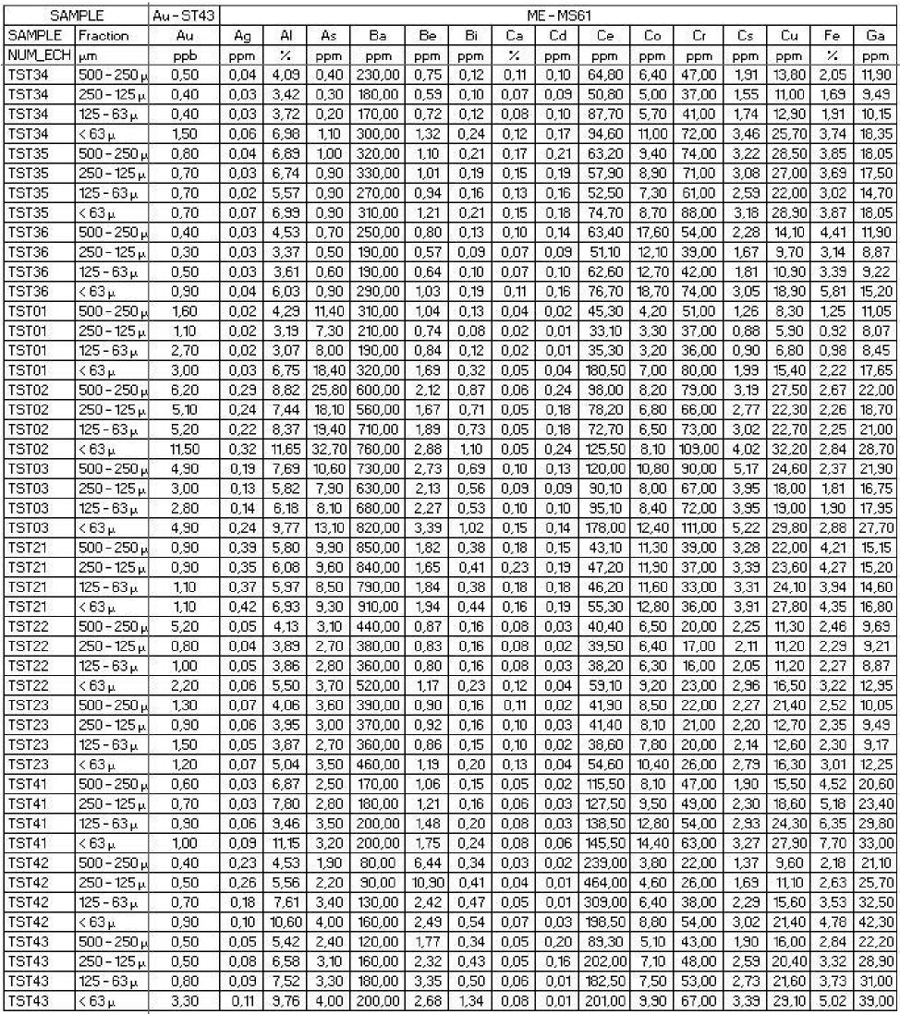
Table 2: Results of the analysis of the methodological orientation test (1/3).

SAMPLE |  | ME - MS61
SAMPLE | Fraction | Ge | Hf | In | K | La | Li | Mg | Mn | Mo | Na | Nb | Ni | P | Pb | Rb | Re
NUM_ECH | 1_,rri | ppm | ppm | ppm | ⁷: | ppm | ppm | "À | ppm | ppm | % | ppm | ppm | ppm | ppm | ppm | ppm
TST34 | 500 - 2501, | 0,08 | 2,90 | 0,05 | 0,60 | 30,30 | 10,60 | 012 | 149,00 | 0,83 | 0,08 | 7,40 | 16,40 | 810,00 | 9,30 | 28,20 | 0,001
TST34 | 250 - 1251, | 0,07 | 2,50 | 0,04 | 0A4 | 23,60 | 8A0 | 0,10 | 123,00 | 0,65 | 0,07 | 7,00 | 13,30 | 660,00 | 7,30 | 21,50 | 0,001
TST34 | 125 - 631, | 0,09 | 3,60 | 0,04 | 0,39 | 41,00 | 8,60 | 0,09 | 133,00 | 0,79 | 0,06 | 8,80 | 15,60 | 770,00 | 8,80 | 2050 | 0,001
TST34 | < 631, | 012 | 10,60 | 0,07 | 0,57 | 44,20 | 15,30 | 014 | 223,00 | 1,48 | 0,07 | 14,50 | 30,60 | 1470,00 | 16,30 | 3650 | 0,001
TST35 | 500 - 250 i.k | 010 | 3,70 | 0,07 | 0,55 | 2310 | 1250 | 014 | 260,00 | 1,80 | 0,06 | 1310 | 3010 | 1670,00 | 15,80 | 3810 | 0,001
TST35 | 250 - 1251, | 0,08 | 3,40 | 0,08 | 0,61 | 26,70 | 12,50 | 0,15 | 240,00 | 1,65 | 0,07 | 12,30 | 29,00 | 1600,00 | 15,20 | 38,20 | 0,001
TST35 | 125 - 63 kt | 0,08 | 2,30 | 0,06 | 0,50 | 24,00 | 1050 | 013 | 132,00 | 1,37 | 0,06 | 10,70 | 25,20 | 1310,00 | 12,30 | 32,00 | 0,001
TST35 | < 631, | 011 | 6,30 | 0,07 | 0,54 | 34,80 | 12,60 | 0,14 | 228,00 | 2,07 | 0,06 | 13,90 | 38,00 | 1600,00 | 15,80 | 37,10 | 0,001
TST36 | 500 - 250 i.k | 0,03 | 3,50 | 0,05 | 0,46 | 28,50 | 310 | 011 | 746,00 | 1,03 | 0,07 | 8,60 | 13,50 | 1230,00 | 10,80 | 27,70 | 0,001
TST36 | 250 - 1251, | 0,06 | 2,70 | 0,04 | 0,36 | 23,70 | 6,60 | 0,08 | 529,00 | 0,73 | 0,06 | 6,80 | 14,20 | 300,00 | 810 | 20,00 | 0,001
TST36 | 125 - 63 kt | 0,08 | 3,30 | 0,04 | 0,36 | 28,80 | 7,00 | 0,08 | 534,00 | 0,88 | 0,05 | 8,40 | 15,80 | 380,00 | 8,80 | 20,80 | 0,001
TST36 | < 631, | 0,09 | 9,30 | 0,07 | 0,52 | 34,80 | 11,10 | 013 | 748,00 | 1,58 | 0,06 | 12,40 | 28,20 | 1680,00 | 14,30 | 33,30 | 0,001
TSTO1 | 500 - 250 i.k | 0,06 | 220 | 0,04 | 0,86 | 23,50 | 10,60 | 0,08 | 134,00 | 0,31 | 0,08 | 8,70 | 1130 | 220,00 | 12,30 | 3020 | 0,001
TSTO1 | 250 - 1251, | 0,02 | 130 | 0,03 | 0,61 | 1650 | 920 | 0,06 | 137,00 | 024 | 0,06 | 6,60 | 8,40 | 160,00 | 810 | 21,40 | 0,001
TSTO1 | 125 - 63 kt | 0,05 | 1,30 | 0,03 | 0,53 | 18,00 | 1120 | 0,06 | 133,00 | 026 | 0,05 | 7,70 | 8,30 | 160,00 | 8,30 | 13,30 | 0,001
TSTO1 | < 631, | 0,19 | 7,80 | 0,06 | 0,81 | 87,30 | 2220 | 011 | 283,00 | 0,54 | 0,06 | 18,60 | 19,90 | 420,00 | 20,90 | 3510 | 0,001
T5T02 | 500 - 2501, | 015 | 4,00 | 0,08 | 0,34 | 43,00 | 13,80 | 015 | 186,00 | 2,46 | 0,10 | 20,30 | 3130 | 670,00 | 56,70 | 4430 | 0,002
TSTO2 | 250 - 1251, | 011 | 320 | 0,07 | 0,91 | 4020 | 18,00 | 0,15 | 153,00 | 1,96 | 0,10 | 17,30 | 2620 | 520,00 | 46,30 | 41,30 | 0,001
T5T02 | 125 - 631, | 011 | 3,60 | 0,08 | 1,15 | 37,80 | 20,30 | 0,15 | 156,00 | 1,33 | 0,13 | 1810 | 27,30 | 550,00 | 4720 | 46,30 | 0,001
TSTO2 | < 631, | 0,15 | 6,30 | 011 | 123 | 62,50 | 26,90 | 0,15 | 178,00 | 3,01 | 0,13 | 2610 | 38,60 | 710,00 | 6510 | 5610 | 0,003
T5T03 | 500 - 2501, | 0,15 | 4,40 | 0,08 | 1,08 | 53,60 | 26,70 | 024 | 278,00 | 1,68 | 0,10 | 2530 | 36,70 | 820,00 | 43,80 | 6630 | 0,001
TSTO3 | 250 - 1251, | 012 | 3,60 | 0,06 | 0,94 | 45,50 | 21,60 | 0,19 | 215,00 | 1,33 | 0,08 | 20,40 | 27,40 | 620,00 | 5210 | 5430 | 0,001
T5T03 | 125 - 631, | 013 | 3,80 | 0,06 | 1,00 | 47,70 | 24,30 | 020 | 236,00 | 1,31 | 0,10 | 21,30 | 28,50 | 720,00 | 42,40 | 5550 | 0,001
TSTO3 | < 63 i.k | 023 | 3,00 | 011 | 112 | 87A0 | 32,50 | 024 | 323,00 | 212 | 0,13 | 3310 | 43,80 | 1030,00 | 6820 | 66,00 | 0,001
TST21 | 500 - 2501, | 0,07 | 220 | 0,11 | 1,34 | 1850 | 3,20 | 020 | 807,00 | 1,38 | 0,12 | 3,10 | 9,40 | 550,00 | 223,00 | 67,00 | 0,001
TST21 | 250 - 1251A | 0,08 | 220 | 011 | 124 | 2010 | 3A0 | 021 | 868,00 | 1,32 | 011 | 310 | 10,40 | 570,00 | 200,00 | 6710 | 0,001
TST21 | 125 - 631, | 0,08 | 220 | 0,11 | 113 | 1340 | 9,40 | 020 | 792,00 | 122 | 0,11 | 7,70 | 10,70 | 540,00 | 13350 | 6420 | 0,001
TST21 | < 63 i.k | 0,03 | 2,70 | 011 | 123 | 23,30 | 10,80 | 023 | 810,00 | 1,37 | 013 | 8,60 | 13,30 | 580,00 | 217,00 | 74,00 | 0,001
TST22 | 500 - 2501, | 0,06 | 210 | 0,04 | 0,97 | 1750 | 7,10 | 016 | 506,00 | 0,69 | 0,12 | 6,90 | 6,50 | 270,00 | 24,30 | 4550 | 0,001
TST22 | 250 -125 kt | 0,06 | 1,30 | 0,04 | 0,83 | 1650 | 6,70 | 014 | 481,00 | 0,64 | 011 | 6,70 | 6,80 | 280,00 | 20,80 | 42,00 | 0,001
TST22 | 125 - 631, | 0,06 | 1,90 | 0,04 | 0,79 | 16A0 | 6,40 | 014 | 465,00 | 0,63 | 0,12 | 6,30 | 6,60 | 270,00 | 21,00 | 40,30 | 0,001
TST22 | < 63 i.k | 0,07 | 3,00 | 0,06 | 1,13 | 25,30 | 3,10 | 0,13 | 651,00 | 0,86 | 014 | 3,40 | 3,80 | 350,00 | 23,50 | 5750 | 0,001
TST23 | 500 - 2501, | 0,07 | 2,40 | 0,04 | 0,85 | 18,30 | 7,00 | 016 | 732,00 | 0,68 | 0,13 | 7,30 | 8,30 | 320,00 | 2110 | 4450 | 0,001
TST23 | 250 - 1251, | 0,05 | 2,00 | 0,04 | 0,80 | 1850 | 6,60 | 0,15 | 636,00 | 0,53 | 0,13 | 7,00 | 8,30 | 320,00 | 19,80 | 4320 | 0,001
TST23 | 125 - 631, | 0,05 | 1,90 | 0,04 | 0,77 | 1750 | 6A0 | 0,15 | 651,00 | 0,63 | 014 | 6,10 | 7,90 | 300,00 | 19,30 | 41,40 | 0,001
TST23 | < 631, | 0,07 | 2,80 | 0,06 | 0,37 | 24,30 | 810 | 013 | 862,00 | 0,78 | 0,15 | 8,50 | 1030 | 370,00 | 25A0 | 53,30 | 0,001
TST41 | 500 - 2501, | 0,09 | 1,60 | 0,08 | 0,48 | 4630 | 1230 | 0,07 | 235,00 | 1,43 | 0,05 | 18,90 | 20,80 | 320,00 | 21,60 | 3350 | 0,001
T5T41 | 250 - 1251, | 011 | 1,30 | 0,03 | 0A6 | 43,50 | 14,80 | 0,03 | 232,00 | 1,54 | 0,04 | 2530 | 24,70 | 380,00 | 24A0 | 3530 | 0,001
TST41 | 125 - 631, | 023 | 2,30 | 0,10 | 0A5 | 4820 | 19,80 | 011 | 337,00 | 2,04 | 0,04 | 29,40 | 32,90 | 480,00 | 23,70 | 38,40 | 0,001
T5T41 | < 631, | 051 | 2,70 | 013 | 0A3 | 48,30 | 2210 | 012 | 368,00 | 2,40 | 0,03 | 34,00 | 37,70 | 570,00 | 3520 | 3310 | 0,001
TST42 | 500 - 2501.k | 020 | 6850 | 028 | 0,55 | 102,50 | 1320 | 0,05 | 268,00 | 230 | 0,06 | 501,00 | 10,30 | 270,00 | 16,40 | 5830 | 0,001
TST42 | 250 - 1251, | 0,35 | 56,00 | 0,41 | 0,62 | 217,00 | 20,60 | 0,06 | 312,00 | 3,42 | 0,06 | 501,00 | 13,50 | 380,00 | 24,00 | 6650 | 0,001
TST42 | 125 - 631A | 024 | 21,70 | 052 | 0,74 | 133,00 | 23,50 | 0,03 | 303,00 | 3,56 | 0,07 | 501,00 | 18,30 | 410,00 | 2310 | 7620 | 0,001
TST42 | < 631, | 018 | 6,80 | 0,13 | 0,72 | 70,80 | 28,20 | 0,12 | 237,00 | 3,87 | 0,07 | 263,00 | 27,70 | 460,00 | 34,30 | 73,30 | 0,001
TST43 | 500 - 250 i.k | 0,08 | 2,60 | 011 | 0,67 | 3330 | 21A0 | 0,03 | 207,00 | 250 | 0,07 | 6120 | 16,30 | 250,00 | 20,70 | 71,00 | 0,001
TST43 | 250 - 1251, | 0,15 | 4,90 | 0,15 | 0,75 | 87,80 | 2410 | 011 | 247,00 | 2,86 | 0,08 | 177,00 | 2320 | 320,00 | 26,30 | 8310 | 0,001
TST43 | 125 - 63 kt | 014 | 6,40 | 017 | 0,80 | 76,60 | 24,80 | 0,12 | 233,00 | 313 | 0,03 | 214,00 | 25,70 | 330,00 | 23,80 | 830 | 0,001
TST43 | < 631, | 0,19 | 5,50 | 021 | 0,73 | 76,80 | 28,30 | 0,14 | 368,00 | 4,05 | 0,08 | 226,00 | 33,30 | 450,00 | 33,30 | 81,30 | 0,001

Table 2 (cont’d) : Results of the analysis of the methodological orientation test (2/3).

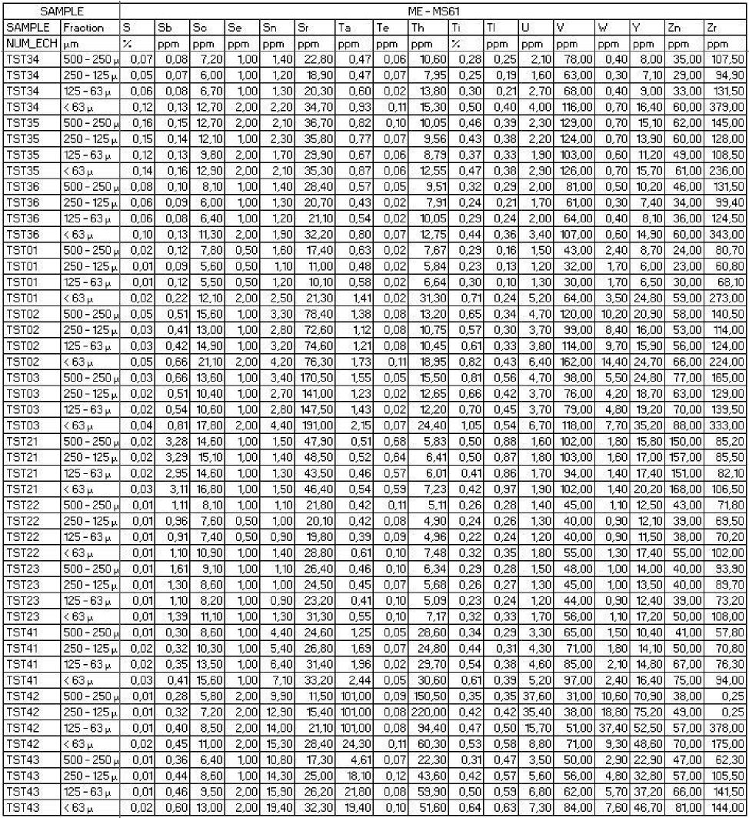
Table 2 (cont’s and end) : Results of the analysis of the methodological orientation test (3/3).

Appendix 2 – QAQC

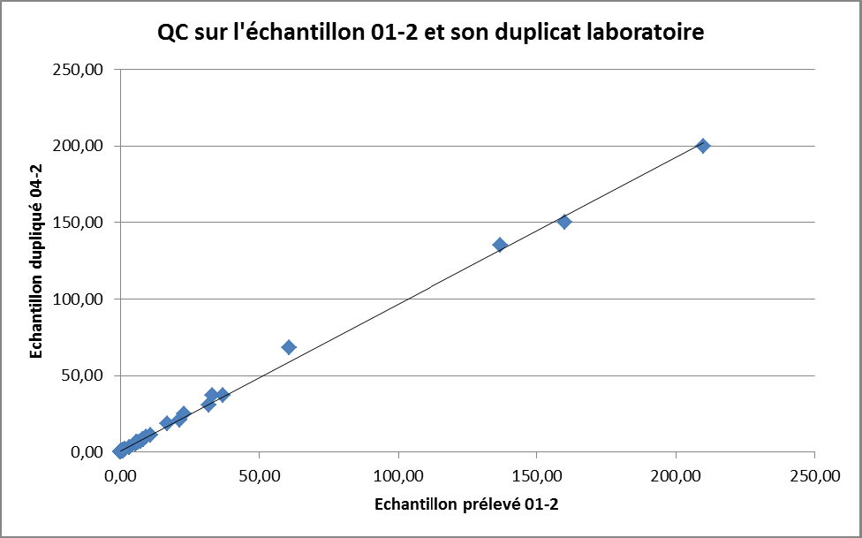
Figure 25: Quality control on sample 01-2 taken at Mborguéné and its laboratory duplicate 04-2 compared to the linear trend function R²=1.

The majority of the elements analyzed have an analytical difference between the sample and its laboratory duplicate of less than 5%. Only Ce and Zr have an11% gap. The further away the points are from the reference curve Y=X, the greater the analytical deviation. The results of the quality control of samples 01-2 and 04-2 are very satisfactory.

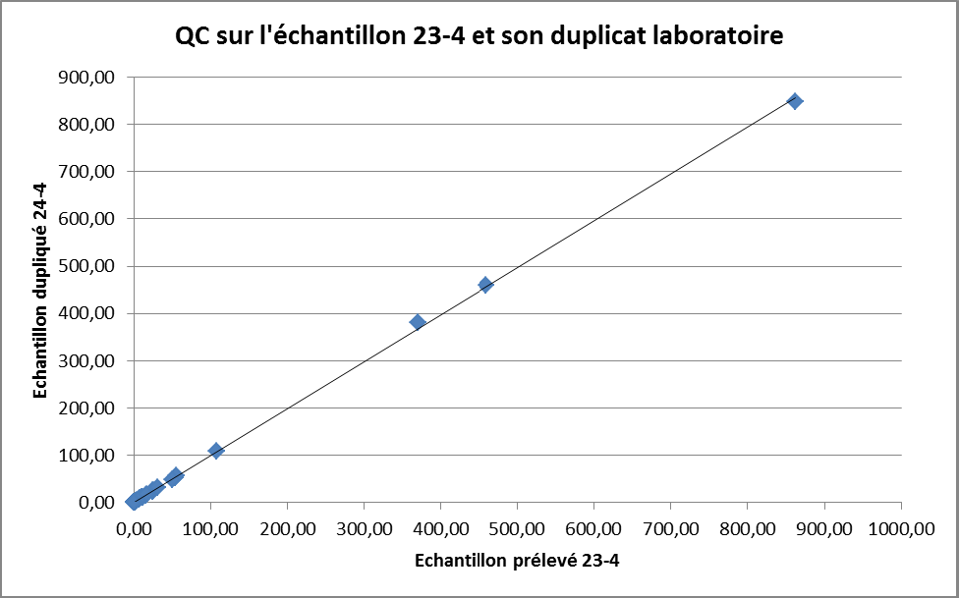
Figure 26: Quality control on sample 23-4 taken at Hosséré Paali and its laboratory duplicate 24-4 compared to the linear trend function R2=1.

The results of the quality control of samples 23-4 and 24-4 are very satisfactory. No analytical anomalies were observed.

